TOXICOLOGY STUDY SHEET

 | BP | HR | R | T | Pupils | Diaphoresis | Mental Status | Other
Anticholinergic | −/↑ | ↑ | ± | ↑ | ↑ | ↓ | Delirium | Dry mucous membranes, flush, urinary retention
Cholinergic | ± | ± | ± | − | ± | ↑ | Normal to depressed | Salivation, lacrimation, urination, diarrhea, bronchorrhea, fasciculations, paralysis
Etoh or Sedative Hypnotic | ↓ | ↓ | ↓ | −/↓ | ± | − | Depressed, agitated | Hyporeflexia, ataxia
Opioids | ↓ | ↓ | ↓ | ↓ | ↓ | − | Depressed | Hyporeflexia
Serotonin toxicity | ↑ | ↑ | −/↑ | −/↑ | −/↑ | ↑ | Normal to agitated delirium | Clonus, tremor, seizures
Sympathomimetics | ↑ | ↑ | ↑ | ↑ | ↑ | ↑ | Agitated | Tremor, seizures diaphoresis
Withdrawal from etoh or bdzs | ↑ | ↑ | ↑ | ↑ | ↑ | ↑ | Agitated, disoriented hallucinations | Tremor, seizures diaphoresis
Withdrawal from opiates | ↑ | ↑ | − | − | ↑ | ↑ | Normal, anxious | Vomiting, rhinorrhea, piloerection, diarrhea, yawning

↑ = increases; ↓ = decreases; ± = variable; − = change unlikely;= ↑ =change more likely

Note that the above table is a spectrum. Depending on the severity toxicity not all vital signs may be indicated as above.

TOXIDROMES CONTINUED:

Anticholinergic: “happy pickers” think diphenhydramine, jimson weed
Antidote: physostigmine (contraindicated if seizure risk or wide QRS)

Cholinergic: Killer B’s bronchorrhea, bronchospasm, bradycardia
Antidote: Atropine, pralidoxime (2-PAM)
DUMBBELS: Diarrhea Urination Miosis/muscle weakness Bronchorrhea Bradycardia Emesis Lacrimation Salivation/sweating

DRUGS OF ABUSE:

Sedative hypnotics: Antidote is flumazenil, not often used for supposed seizure risk in chronic users (can be considered to prevent intubation or invasive workup such as LP).

Opioids: antidote Narcan .04mg

Opioid mimic: clonidine, causes pinpoint pupils, bradycardia, sedation, respiratory depression. Treatment is still the same: naloxone

GHB: Pt. comes in comatose with normal vitals, suddenly wakes up and self extubates

PCP: mydriasis, rage, delusions, amnesia, vertical and rotary nystagmus. Rx with benzos

TOXIC ALCOHOLS:

Methanol: metabolized to Formic Acid (ocular toxicity)
Treat with Fomepizole (ADH blocker) and dialysis
Ethylene Glycol: metabolized to Glycolic and Oxalic Acid (renal toxicity)
Treat with Fomepizole (ADH blocker) and dialysis
Isopropanol: metabolized to Acetone *Ketosis without acidosis*

OVER THE COUNTER MEDICATIONS:

APAP: 4 hour level >150 treat with NAC.
Toxic range: >150mg/kg (kids) or 7.5g (adults)
Rumack-Mathew nomogram can be applied to ACUTE ingestions only

Aspirin: Toxic range: >150mg/kg. Tinnitus, Tachypnea, Hyperthermia, mixed resp alkalosis/metabolic acidosis
Treatment: Bicarb 1-2mEq/bolus followed by drip.
Avoid intubation whenever possible
HD for: 1) Altered mental status or pulmonary edema
2) An acute level of > 100
3) An acute level of >90 with
3) Failure to respond to supportive care (bicarb, fluids)

NSAIDS: metabolic acidosis in massive overdose, can cause renal failure chronically.

SYNDROMES OF HYPERTHERMIA:

Malignant hyperthermia: first sign is rise in end tidal CO2, hyperthermia, rigidity, tachycardia, hypertension. Antidote: Dantrolene
Classic case is after OR case from inhaled anesthetics, can also be caused by succinylcholine

Serotonin Syndrome: Tachycardia, HTN, hyperthermia, hyperreflexia, myoclonus, lower extremity rigidity, rhabdomyolysis, tremor
Antidote: cyproheptadine

NMS: Diffuse rigidity, including upper extremities, rhabdomyolysis, tachycardia, HTN, hyperthermia
Antidote: bromocriptine, benzos

PSYCHIATRIC MEDICATIONS:

TCAs: “seizures, coma, death” sodium channel blockade, ekg may show terminal R in aVR, QRS >100 predictive of seizures >160 predictive of dysrhythmias
Treat with sodium bicarb

Lithium: Acute (GI distress) vs. Chronic (Neuro); can be acute on chronic.
Usually occurs with renal impairment, lithium is radiopaque get abd XR
Treatment: Hydrating the patient
HD if evidence AMS, renal failure or level 4.0 in acute or 2.5 chronic

METALS:

Iron: GI distress (vomiting); may be accompanied by hyperglycemia, leukocytosis
Radiopaque, get abdominal x-ray
5 Stages:
1. GI irritation (30min – 6hrs)
2. Recovery from GI symptoms (6-24hrs)
3. Shock and metabolic acidosis (6-72hrs)
4. Fulminant Hepatic Failure (12-96hrs)
5. GI mucosa healing leads to scarring and bowl obstruction (2-6weeks)
Antidote: Deferoxamine for level >500

Lead: WBI especially if lead visible on x-ray
Treatment: if symptomatic with encephalopathy or level >100 Rx BAL (British anti-lewisite) first then EDTA;
If asymptomatic child >45 or adult >89 Rx with DMSA (succimer)

Arsenic: Garlic breath; Rx with BAL (British anti-Lewisite) or DMSA if can tolerate PO

Mercury: Rx with BAL (British anti-Lewisite) or DMSA if can tolerate PO
CELLULAR ASYPHYXIANTS

Cyanide: Hemodynamic instability, setting of house fire, very high lactate
Antidote: Hydroxycobalamin
Old kit: sodium nitrate, amyl nitrate, sodium thiosulfate

Carbon Monoxide: Headache, produced by anything causing combustion (ie engines, bbq’s) can also be in setting of a house fire
Treat with HBO if Level >25%, >15% in pregnant women, or any level with signs of end organ damage (syncope, STEMI, AMS, seizures)

Methemoglobinemia: cyanosis, O2 sat 85% not correcting with oxygen. May see chocolate colored blood. Common offending agents benzocaine, dapsone
Antidote: Methylene blue

CARDIAC MEDS AND HYPOGLYCEMICS:

Digoxin Toxicity: Bradaycardia, AV blocks, bidirectional VTACH, slow afib
Usually occurs with renal impairment
Must check a level 6 hours after last dose patient has taken or the level will be falsely elevated
Give Digifab if ectopy on ekg, hyperK >5, or renal failure, significantly elevated dig level
Digifab dosing = [weight (kg) x concentration level (ng/mL)/100] *round up to nearest number of vials

Beta Blocker: Bradycardia hypotension. Rx with glucagon, high dose insulin

Calcium Channel Blocker: Bradycardia hypotension. Rx with calcium, high dose insulin

Sulfonylurea: Hypoglycemia. Rx with Octreotide

MALA (Metformin Associated Lactic Acidosis): Usually in setting of renal failure causing decreased excretion of metformin. Leads to usually a severe lactic acidosis in the setting or relatively preserved mental status. Treatment is HD. Can use bicarb to temporize

CAUSTICS:

Hydrofluoric Acid: seen in window/glass etching. Pain out of proportion to skin findings, causes hypocalcemia, hypomagnesemia, QTc prolongation, cardiac arrythmia and death
Treatment: decontamination, calcium topically (if systemic illness give IV)

Bleach: Sodium Hypochlorite; Stridor, drooling, or vomiting needs endoscopy within 12hrs

ANTICONVULSANTS

Na channel blockade: phenytoin, carbamazepine, topiramate, VPA
GABA antagonism: phenobarbital
Calcium channel blockade: Gabapentin, pregabalin, VPA
Phenytoin: cerebellar symptoms, ataxia, slurred speech, nystagmus
Carbamazepine: Can present with anticholinergic toxidrome and qrs widening
VPA toxicity results in hyperammonemia rx with L-carnetine

Note: intractable seizures and “recently treated for TB” think isoniazid give B6/pyridoxine
LOCAL ANESTHETICS:

“Neurotoxicity before cardiotoxicity”
Treatment is intralipid

Lidocaine toxic dose without epi 4.5mg/kg, with epi 7mg/kg

1% solution means 1G / 100mL or 1000mg / 100mL = 10mg/mL
2% solution means 2G / 100mL or 2000mg / 100mL = 20mg/mL

Examples:
Would take approx. ~30cc (4.5mg x 70kg = 315mg / 10mg = 31.5cc) of 1% lidocaine without epi for toxicity in a 70kg adult.

Would take approx. ~15cc (4.5mg x 70kg = 315mg / 20mg = 15.75cc) of 2% lidocaine without epi for toxicity in a 70kg adult.

Would take approx. ~50cc (7mg x 70kg = 490mg / 10mg = 49cc) of 1% lidocaine with epi for toxicity in a 70kg adult.

Would take approx. ~25cc (7mg x 70kg = 490mg / 20mg = 24.5cc) of 2% lidocaine with epi for toxicity in a 70kg adult.

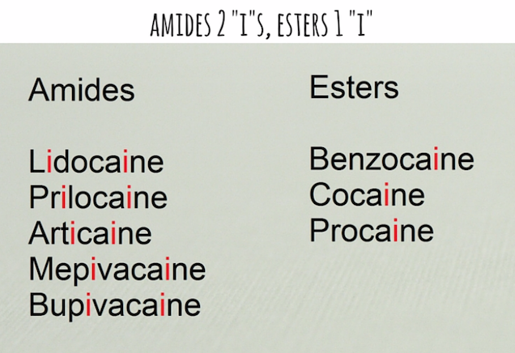
ENVIRONMENTAL:

Radiation: absolute lymphocyte count at 48 hrs <1200 predictor of bad outcome

Spiders:
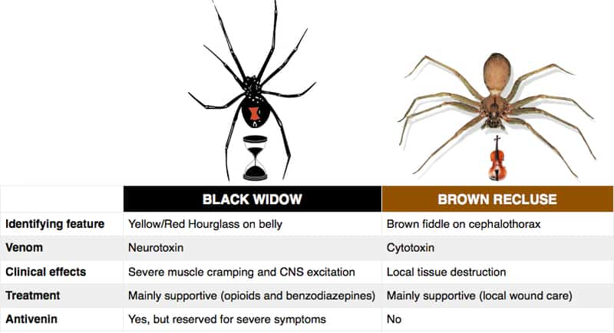
Note: black widow envenomation can cause severe muscle spasms (even of abdominal muscles) can be confused for acute abdomen, especially in pediatrics.

Snakes:

Crotalids (pit vipers): cottonmouths, water moccasins, and rattlesnakes
Triangular head, elliptical pupils, and two curved fangs.
Causes coagulopathy, necrosis, swelling. Rx with Cro-Fab.
The treatment for compartment syndrome from crotalid envenomation is Cro-Fab, not fasciotomy

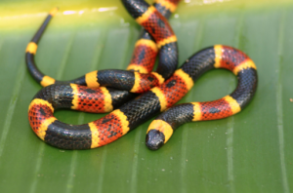
Elapids: Coral snake (above) Neurotoxicity leading to weakness, respiratory paralysis; “Red on yellow, kill a fellow. Red on black, venom lack”

Scorpions: Centuroides (bark scorpion)
Hyperthermia, hypertension, nystagmus, drooling, mydriasis, pancreatitis
Rx with benzos and antivenom (only if systemic illness or very old and very young)

Plants containing cardiac glycosides (know what they look like; see plant ppt):
Oleander
Yellow Oleander
Foxglove
Lily of the Valley
Red squill

Mushrooms: In general (there are always exceptions) If nausea and vomiting occurs < 6 hrs this is a good prognostic indicator
Amanita phalloides (Death Cap), hepatoxicity, GI manifestations delayed >6 hrs.

Ciguatoxin: large fish, barracuda, grouper, etc. heat stabile
Temperature reversal, sensation of loose teeth are classic symptoms, also GI upset
Supportive care

Scombroid: histamine release, flushing, GI upset, peppery taste. Rx with diphenhydramine.

***This is meant to be a quick reference study guide. A lot of the toxicity and treatments mentioned in this paper are very nuanced and at times controversial. If there are ever any questions with the management of a poisoned patient please consult our medical toxicology service. **** 516-975-1300

