Academic Opportunities – Fellowship Programs
Progressive Emergency Physicians is seeking dedicated and energetic new physicians who are interested in participating in our Emergency Medicine Fellowship Training Programs.
Progressive Emergency Physicians
1236 RXR Plaza, Uniondale, NY 11556
Tel.: (516) 252-3939
www.Pephealth.net
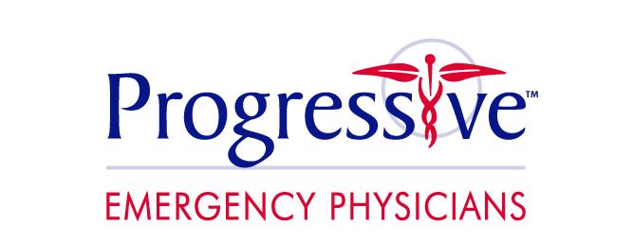

Joining our TEAM

If you are interested in joining our team at Progressive, please submit your CV to Progressive Emergency Physicians at http://pephealth.net/for-clinicians/.

Progressive Facts
- Progressive staffs, manages, and consults for Hospital Emergency Departments, Hospitalist Programs and Intensive Care Units
- We are a democratic group managed by emergency medicine physicians with extensive leadership experience
- Competitive salary
- Generous benefits
  - Health, Dental, Vision
  - Malpractice (occurrence)
  - 401k
  - 4 weeks PTO
  - CME stipend
- Academic opportunities at three New York Institutions
  - Good Samaritan Hospital Medical Center in West Islip, New York
  - St. Joseph Hospital in Bethpage, New York
  - St. John’s Episcopal Hospital in Far Rockaway, New York

Fellowship Training Opportunities
- Observation Medicine: One-year program aimed at developing experts in Observation medicine. Progressive has founded and operates several EM Clinical Decision Units and hosts several leaders in the field.
- Administration and Leadership: One-year program aimed at developing future leaders in Emergency Medicine and healthcare administration. Fellows will be exposed to all aspects of EM in academic medical centers, community hospitals and private democratic groups.
- Emergency Ultrasound: One-year program designed to develop expertise in all emergency medicine ultrasound applications, education, research, and quality assurance. The program is led by national leaders and the EUS division is comprised of 8 fellowship-trained physicians.

